**Develop an android application to perform Text to Speech and Speech to Text**

**AIM:**

**To implement an android application to perform text to speech and speech to text.**

**PROCEDURE:**

**Step 1: File → New Project Provide the application name and Click “Next”**

**Step 2: Select the target android devices, Select the minimum SDK to run the application. Click “Next”.**

**Step 3: Choose the activity for the application (By default choose “Blank Activity). Click “Next”.**

**Step 4: Enter activity name and click "Finish".**

**Step 5: Edit the program.**

**Step 6: Run the application, 2-ways to run the application**

**1. Running through emulator**

**2. Running through mobile device**

**CODE:**

**activity_main.xml:**

**<?xml version="1.0" encoding="utf-8"?>**

**<androidx.constraintlayout.widget.ConstraintLayout**

**xmlns:android="http://schemas.android.com/apk/res/android"**

**xmlns:app="http://schemas.android.com/apk/res-auto"**

**xmlns:tools="http://schemas.android.com/tools"**

**android:layout_width="match_parent"**

**android:layout_height="match_parent"**

**tools:context=".MainActivity">**

**<EditText**

**android:id="@+id/etInput"**

**android:layout_width="0dp"**

**android:layout_height="wrap_content"**

**android:hint="Enter text to speak"**

**android:padding="16dp"**

**app:layout_constraintTop_toTopOf="parent"**

**app:layout_constraintStart_toStartOf="parent"**

**app:layout_constraintEnd_toEndOf="parent"**

**android:layout_marginHorizontal="16dp"**

**android:layout_marginTop="16dp" />**

**<Button**

**android:id="@+id/btnTextToSpeech"**

**android:layout_width="wrap_content"**

**android:layout_height="wrap_content"**

**android:text="Text to Speech"**

**app:layout_constraintTop_toBottomOf="@id/etInput"**

**app:layout_constraintStart_toStartOf="parent"**

**app:layout_constraintEnd_toEndOf="parent"**

**android:layout_marginTop="16dp" />**

**<Button**

**android:id="@+id/btnSpeechToText"**

**android:layout_width="wrap_content"**

**android:layout_height="wrap_content"**

**android:text="Speech to Text"**

**app:layout_constraintTop_toBottomOf="@id/btnTextToSpeech"**

**app:layout_constraintStart_toStartOf="parent"**

**app:layout_constraintEnd_toEndOf="parent"**

**android:layout_marginTop="16dp" />**

**<TextView**

**android:id="@+id/tvSpeechOutput"**

**android:layout_width="0dp"**

**android:layout_height="wrap_content"**

**android:padding="16dp"**

**android:text="Speech output will appear here"**

**android:textSize="16sp"**

**android:textColor="@android:color/black"**

**app:layout_constraintTop_toBottomOf="@id/btnSpeechToText"**

**app:layout_constraintStart_toStartOf="parent"**

**app:layout_constraintEnd_toEndOf="parent"**

**android:layout_marginHorizontal="16dp"**

**android:layout_marginTop="16dp" />**

**</androidx.constraintlayout.widget.ConstraintLayout>**

**MainActivity.java:**

**package com.example.speechapp;**

**import android.content.Intent;**

**import android.os.Bundle;**

**import android.speech.RecognizerIntent;**

**import android.speech.tts.TextToSpeech;**

**import android.view.View;**

**import android.widget.Button;**

**import android.widget.EditText;**

**import android.widget.TextView;**

**import android.widget.Toast;**

**import androidx.annotation.Nullable;**

**import androidx.appcompat.app.AppCompatActivity;**

**import java.util.ArrayList;**

**import java.util.Locale;**

**public class MainActivity extends AppCompatActivity {**

**private TextToSpeech textToSpeech;**

**private static final int SPEECH_REQUEST_CODE = 1;**

**private EditText etInput;**

**private TextView tvSpeechOutput;**

**@Override**

**protected void onCreate(Bundle savedInstanceState) {**

**super.onCreate(savedInstanceState);**

**setContentView(R.layout.activity_main);**

**etInput = findViewById(R.id.etInput);**

**tvSpeechOutput = findViewById(R.id.tvSpeechOutput);**

**Button btnTextToSpeech = findViewById(R.id.btnTextToSpeech);**

**Button btnSpeechToText = findViewById(R.id.btnSpeechToText);**

**// Initialize Text-to-Speech**

**textToSpeech = new TextToSpeech(this, status -> {**

**if (status == TextToSpeech.SUCCESS) {**

**int result = textToSpeech.setLanguage(Locale.getDefault());**

**if (result == TextToSpeech.LANG_MISSING_DATA || result == TextToSpeech.LANG_NOT_SUPPORTED) {**

**Toast.makeText(this, "Language not supported", Toast.LENGTH_SHORT).show();**

**}**

**} else {**

**Toast.makeText(this, "Text-to-Speech initialization failed", Toast.LENGTH_SHORT).show();**

**}**

**});**

**// Text to Speech Button Click**

**btnTextToSpeech.setOnClickListener(v -> speakOut());**

**// Speech to Text Button Click**

**btnSpeechToText.setOnClickListener(v -> promptSpeechInput());**

**}**

**// Text to Speech**

**private void speakOut() {**

**String text = etInput.getText().toString();**

**if (text.isEmpty()) {**

**Toast.makeText(this, "Please enter text to speak", Toast.LENGTH_SHORT).show();**

**return;**

**}**

**textToSpeech.speak(text, TextToSpeech.QUEUE_FLUSH, null, null);**

**}**

**// Speech to Text**

**private void promptSpeechInput() {**

**Intent intent = new Intent(RecognizerIntent.ACTION_RECOGNIZE_SPEECH);**

**intent.putExtra(RecognizerIntent.EXTRA_LANGUAGE_MODEL, RecognizerIntent.LANGUAGE_MODEL_FREE_FORM);**

**intent.putExtra(RecognizerIntent.EXTRA_LANGUAGE, Locale.getDefault());**

**intent.putExtra(RecognizerIntent.EXTRA_PROMPT, "Speak now...");**

**try {**

**startActivityForResult(intent, SPEECH_REQUEST_CODE);**

**} catch (Exception e) {**

**Toast.makeText(this, "Speech recognition is not available", Toast.LENGTH_SHORT).show();**

**}**

**}**

**@Override**

**protected void onActivityResult(int requestCode, int resultCode, @Nullable Intent data) {**

**super.onActivityResult(requestCode, resultCode, data);**

**if (requestCode == SPEECH_REQUEST_CODE && resultCode == RESULT_OK && data != null) {**

**ArrayList<String> results = data.getStringArrayListExtra(RecognizerIntent.EXTRA_RESULTS);**

**if (results != null && !results.isEmpty()) {**

**tvSpeechOutput.setText(results.get(0));**

**}**

**}**

**}**

**@Override**

**protected void onDestroy() {**

**if (textToSpeech != null) {**

**textToSpeech.stop();**

**textToSpeech.shutdown();**

**}**

**super.onDestroy();**

**}**

**}**

**OUTPUT:**

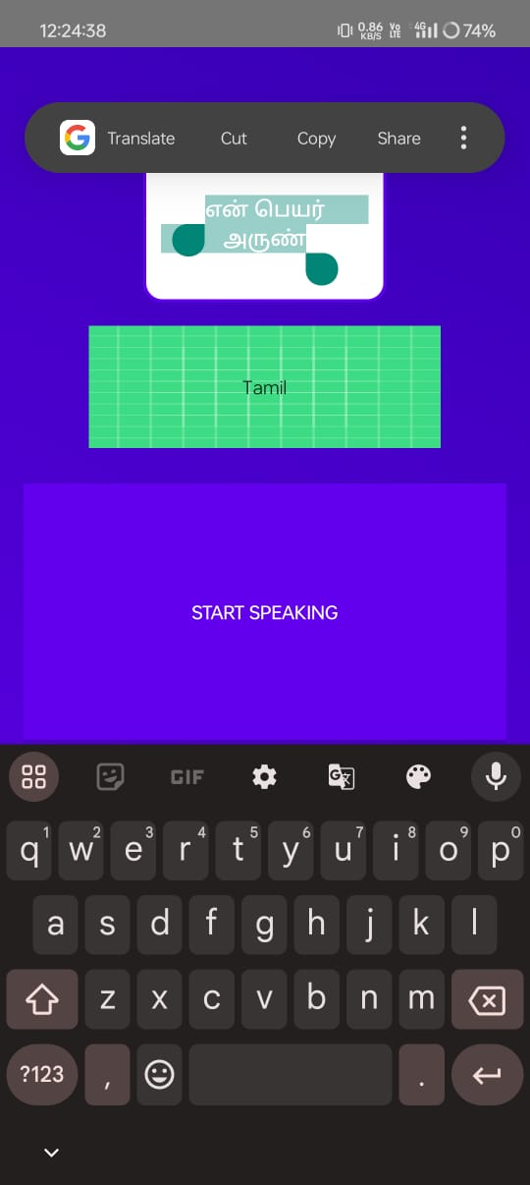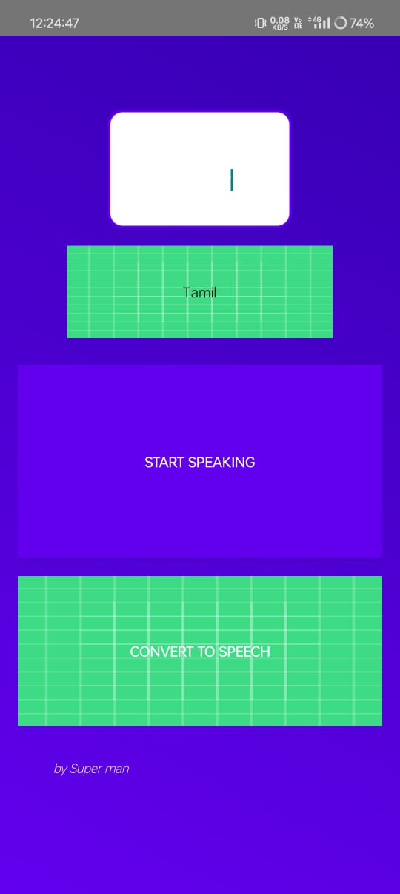

**RESULT:**

**THE PROGRAM IS CREATED AND EXECUTED SUCCESSFULLY.**